Checking internet configuration

In order to check the device configuration there are some commands and graphical tools that can be used. Always make sure the IP (internet protocol) address is configured properly, Default gateway is working properly.

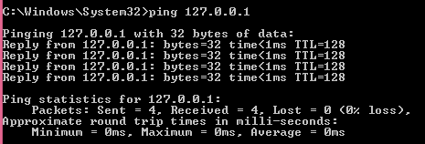

First thing that should be done is to check your connectivity to Network interface card(127.0.0.1) try to ping (127.0.0.1) then Analyze your IP information obtained from the command (ipconfig) make sure your IP addresses being uses inside the LAN(local area network belongs to same class.

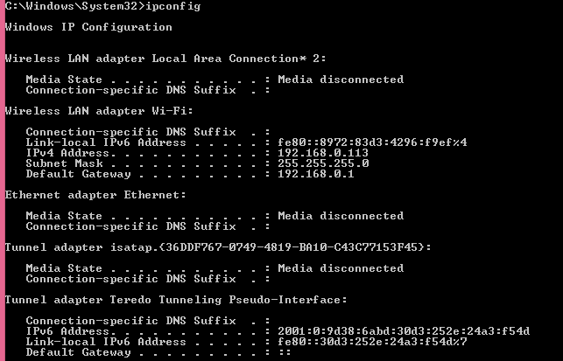

Incase if your network is consisting of many router, switches and PC then we can use the command tracert (in window based OS) while we use traceroute (In Linux, cisco) in order to determine exactly where packets are being dropped or how data is travelling from one location to another location. It measures transit delays of packets across internet protocol (IP) network.

The history of route is recorded as round trip timer of packets received from each successive host(remote host) in the route and then the sum of mean timer in each hop is measure of total time spend to establish the connection so in this way we can identify actually the problem is occurring another advantage of using this command is that for example one company has two offices one is located in London and second in Kualalumpur and third in Indonesia so by sitting in Kualalumpur office A network administrator can use this command in order to identify where the problem is occurring .

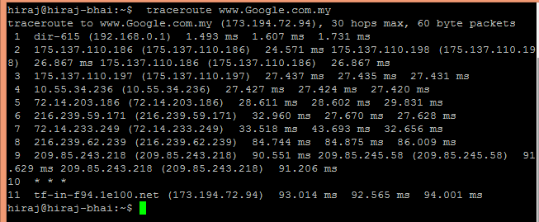

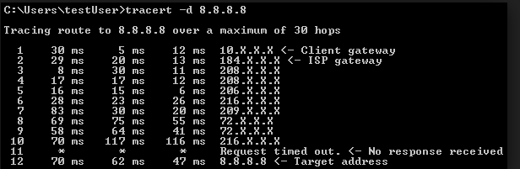

Checking layer two connectivity

Layer two is refers as Data link layer in OSI (open system interconnection). The data link layer is concerned with moving data across the physical links in the network. Switches and bridges work at this layer and they use the mac (media access control) address to forward the data.

If you want to list the summary information about the devices connected to cisco router or switch this is where CDP (cisco discovery protocol) comes in to get the information.

***Remember: CDP gives only information that’s directly connected to that device.***

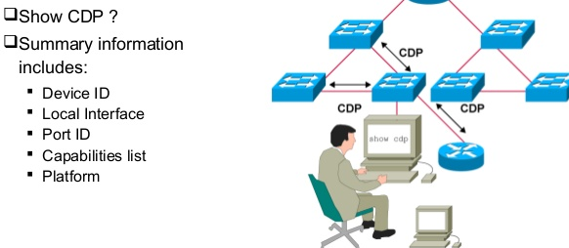

In cisco switches, routers use the command “show cdp neighbor “in order to get the information about the devices that are directly connected to that particular device. In the example shown below **switch (S1)** will give only information about the devices that are directly connected to it in this case **S2,R3, and R2.**

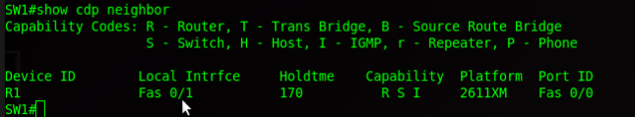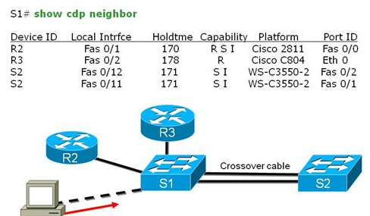

CDP(Cisco discovery protocol) is cisco proprietary and it did not work on the equipment of other vendors.

LLDP (Link layer discovery protocol) is a standard protocol and can be used for internetworking among the different vendor.

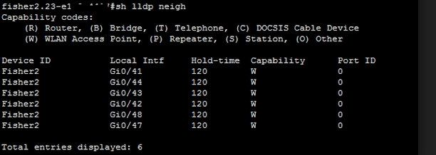CDP (cisco discovery protocol) is only used on cisco devices while LLDP (link layer discovery protocol) can be used on cisco as well on the devices manufactured by other vendors.

**DNS and default gateway problems**

**Verify the connectivity between PC IP (internet protocol) address, default-gateway, DNS(domain name system) and DHCP(dynamic host configuration protocol)**

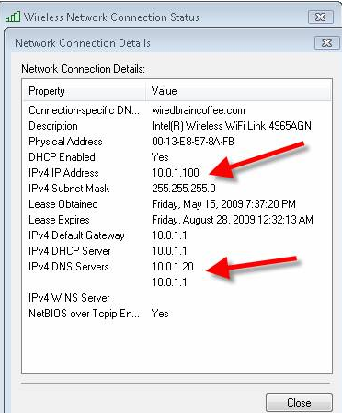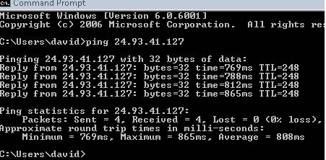

When you are facing internet connectivity problem just right click on your internet connection and choose troubleshoot problem it will try to find the problem basic problem can be solved by using this technique .

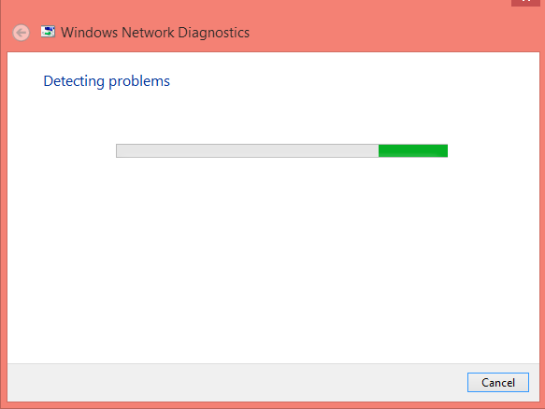



If the DNS(domain name system) is not configured properly then you may encountered an error “DNS server is not responding” though this is not very common problem but it can occur if address is being assigned by DHCP server and in DHCP server DNS(Domain name system) is configured improperly.

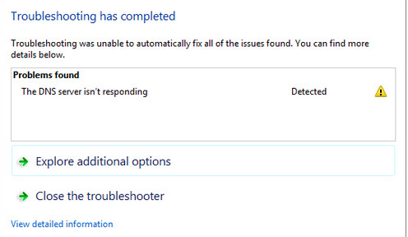

But before trying anything complex try to load the website from the different browser if it is not related to browser related problem you can clear the browser cache .Most probably problem will be solved.

Even after making these changes the problem exists then in order to solve the DNS (domain name system) issue follows these simple steps.

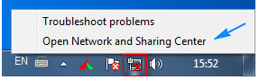Right click on your **network** Icon. Then click “**open system and sharing center”**

After that click on **Local area connection**  and then in new window click **properties**

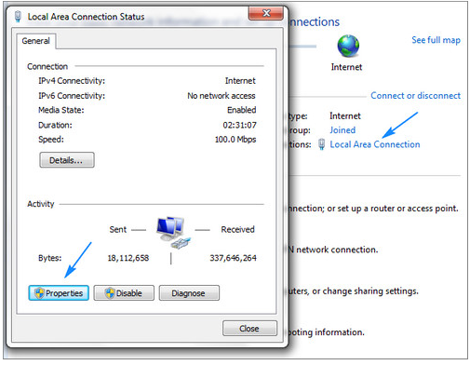

Afterward, select **internet protocol version 2(TCP/ipv4)** and then hit **properties** again**.**

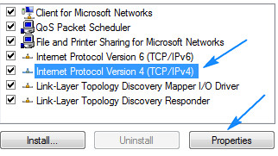

in that window a radio button that says **use the following DNS server Addresses**  modify them according to your need . if in your organization you are using DNS server give that server IP addresses else you can use **Google public DNS server(8.8.8.8)** and then press **OK.**

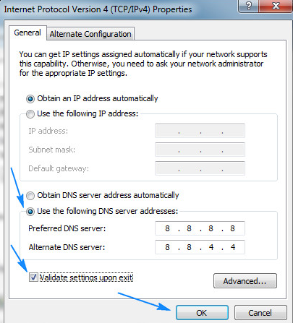

Quick Quiz

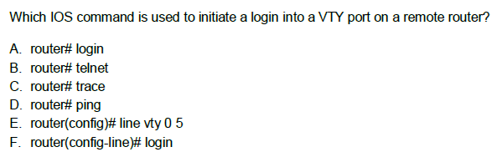

Answer: Telnet or SSH is used to make Remote access to device.

**Which protocol gives the layer2 (data link layer ) information**

**A. telnet**

**B. CDP**

**C. UDP**

**D. SMTP**

**E. POP3**

Answer: CDP (cisco discovery protocol) is data link layer protocol which is used to measure to layer two connectivity.

**Which of these two functions are performed by the Router (choose two)**

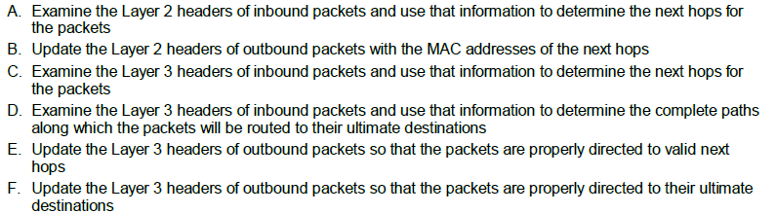

Answer: BC



**Destination.**